**Day 3 - API Integration Report – Ecommerce and Rental Commerce**

**Steps for Day 3:**

1. **Understand the Provided API:**

I first customize my API by creating another next js project just for API customization and my API URL end point is /furniture-api

Customizable API Link: <https://template-6-data.vercel.app/api/furniture-api>

API was not according to my day 2 schema and according to my website UI. I added images in API, add rental and stock option also. From This I learn how to customize API manually  
  
**2. Adjustments Made to Schemas.**

Compare your existing Sanity CMS schema (created on Day 2) with the API data structure.  
  
I validate and adjust my schema according to the planning schema that I have done on day 2 documentation.

**Addition:**

API Field:

* Change title (related to real product)
* Change tags
* Make and Change the description short.
* Available for Rental
* Stock
* 4 images
* Rental Price Per Day

Schema Type and Field:

* Document type name change --- it was product --- I convert it into furniture.
* I added slug for customize URL.
* I added hotspot in image.
* In schema the image was one. I added Image Array.
* Added isStock Field which is Boolean.
* Added Stock Quantity field
* Added isAvailableForRental Field which is Boolean
* Added RentalPricePerDay Field.

1. Data Migration Options:

Manual Import:

After Customizing the Provided API , I use Manual Import as mentioned above I customized the Provided API then I have to move towards Manual Import and I do Manual Import. And I migrate the data to Sanity through migrate.mjs file.

Migration steps and tools used:

I used migration script to migrate data from API to Sanity.

API Calls:

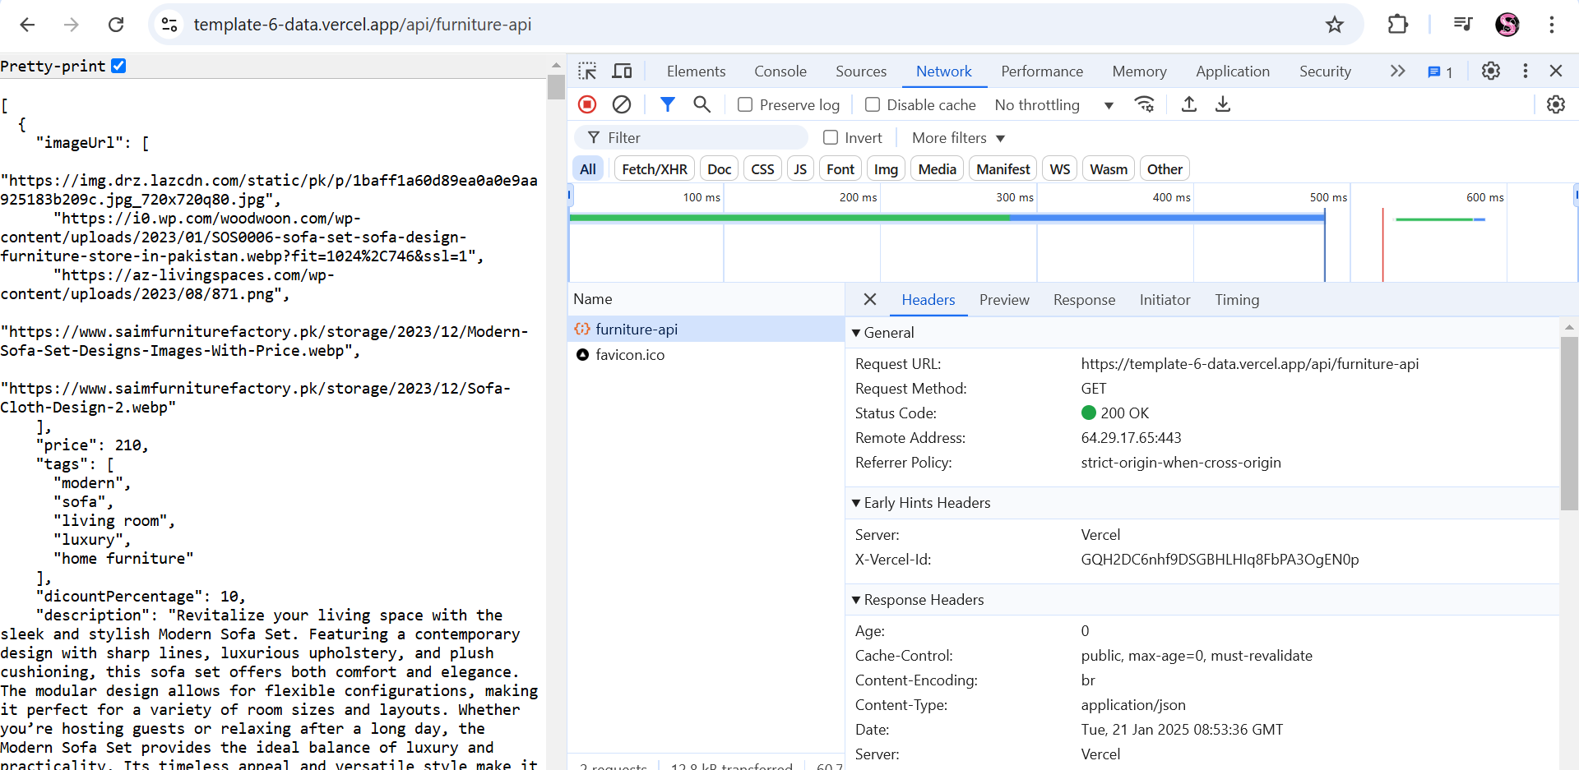

1. **API Integration in Next.js:**

Step 1: Create Utility Functions --- Created

Step 2: Render Data in Components --- Successfully fetched show in the last.

Step 3: Test API Integration

* I tested my api on postman.
* API data fetched in postman.
* status 200 ok.

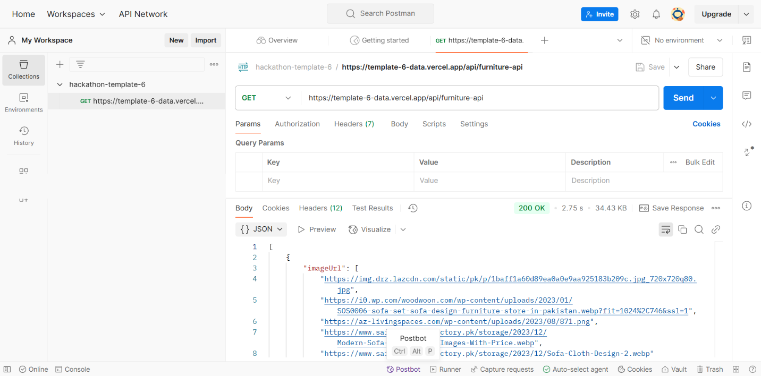

**Code snippets for API integration and migration scripts.**

// Import environment variables from .env.local

import dotenv from "dotenv";

dotenv.config();

// Import the Sanity client to interact with the Sanity backend

import { createClient } from "@sanity/client";

// Load required environment variables

const {

  NEXT_PUBLIC_SANITY_PROJECT_ID, // Sanity project ID

  NEXT_PUBLIC_SANITY_DATASET, // Sanity dataset (e.g., "production")

  NEXT_PUBLIC_SANITY_TOKEN, // Sanity API token

  BASE_URL = "https://template-6-data.vercel.app", // API base URL for products and categories

} = process.env;

// Check if the required environment variables are provided

if (!NEXT_PUBLIC_SANITY_PROJECT_ID || !NEXT_PUBLIC_SANITY_TOKEN) {

  console.error(

    "Missing required environment variables. Please check your .env.local file."

  );

  process.exit(1); // Stop execution if variables are missing

}

// Create a Sanity client instance to interact with the target Sanity dataset

const targetClient = createClient({

  projectId: NEXT_PUBLIC_SANITY_PROJECT_ID, // Your Sanity project ID

  dataset: NEXT_PUBLIC_SANITY_DATASET || "production", // Default to "production" if not set

  useCdn: false, // Disable CDN for real-time updates

  apiVersion: "2025-01-18", // Sanity API version

  token: NEXT_PUBLIC_SANITY_TOKEN, // API token for authentication

});

// Function to upload an image to Sanity

async function uploadImageToSanity(imageUrl) {

  try {

    // Fetch the image from the provided URL

    const response = await fetch(imageUrl);

    if (!response.ok) throw new Error(`Failed to fetch image: ${imageUrl}`);

    // Convert the image to a buffer (binary format)

    const buffer = await response.arrayBuffer();

    // Upload the image to Sanity and get its asset ID

    const uploadedAsset = await targetClient.assets.upload(

      "image",

      Buffer.from(buffer),

      {

        filename: imageUrl.split("/").pop(), // Use the file name from the URL

      }

    );

    return uploadedAsset._id; // Return the asset ID

  } catch (error) {

    console.error("Error uploading image:", error.message);

    return null; // Return null if the upload fails

  }

}

async function uploadImagesToSanity(imageUrls) {

  const uploadedImages = await Promise.all(

    imageUrls.map((url) => uploadImageToSanity(url))

  );

  return uploadedImages

    .filter((imageId) => imageId) // Filter out failed uploads

    .map((imageId) => ({

      _type: "image",

      asset: {

        _ref: imageId,

      },

    }));

}

// Main function to migrate data from REST API to Sanity

async function migrateData() {

  console.log("Starting data migration...");

  try {

    // Fetch products from the REST API

    const productsResponse = await fetch(`${BASE_URL}/api/furniture-api`);

    if (!productsResponse.ok) throw new Error("Failed to fetch products.");

    const productsData = await productsResponse.json(); // Parse response to JSON

    // Migrate products

    for (const product of productsData) {

      console.log(`Migrating product: ${product.title}`);

      const productImages = await uploadImagesToSanity(product.imageUrl);

      // Prepare the new product object

      const newProduct = {

        _type: "furniture",

        title: product.title,

        description: product.description,

        productImage: productImages,

        price: product.price,

        dicountPercentage: product.dicountPercentage,

        isNew: product.isNew,

        isStock: product.isStock,

        stock: product.stock,

        availableForRental: product.availableForRental,

        rentalPricePerDay: product.rentalPricePerDay,

        tags: product.tags,

      };

      // Save the product to Sanity

      const result = await targetClient.create(newProduct);

      console.log(`Migrated product: ${product.title} (ID: ${result._id})`);

    }

    console.log("Data migration completed successfully!");

  } catch (error) {

    console.error("Error during migration:", error.message);

    process.exit(1); // Stop execution if an error occurs

  }

}

// Start the migration process

migrateData();

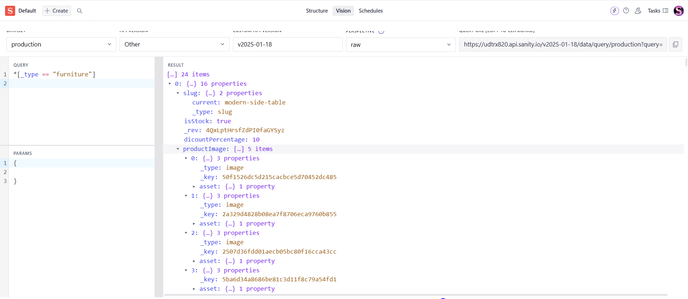Data Migrated to Sanity:

Product Fetch And Display In UI Dynamically:

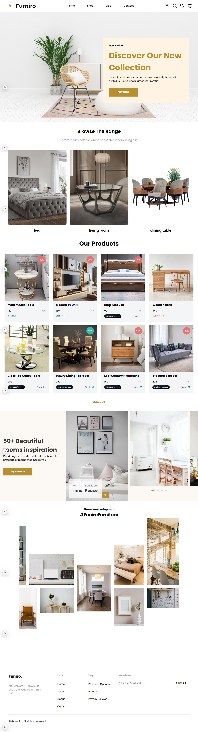

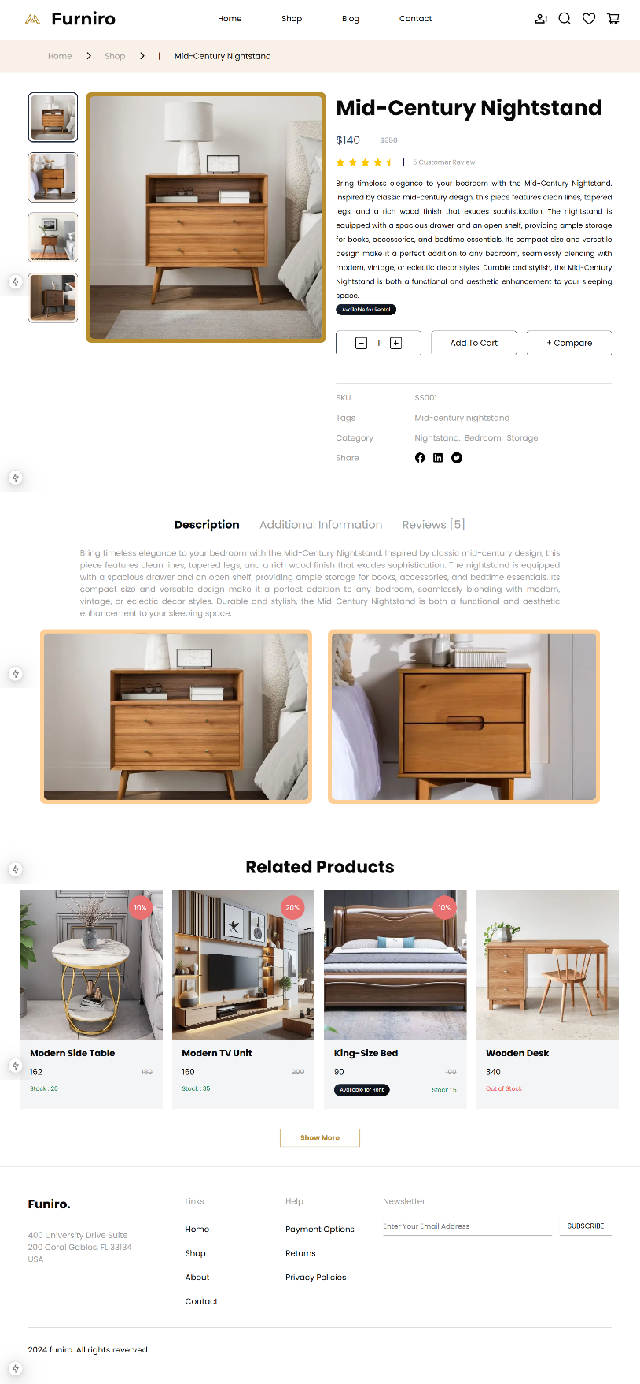

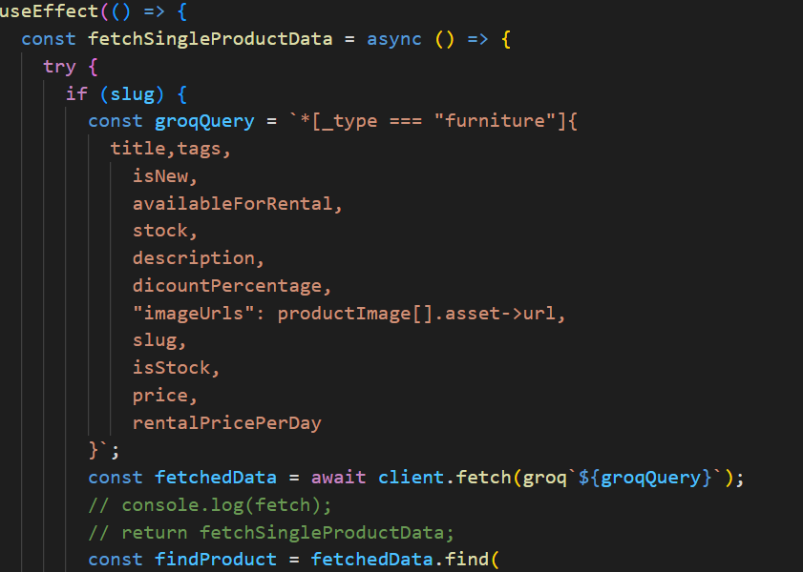Log Error By Adding ( = )

Error Page in loading Product Page:

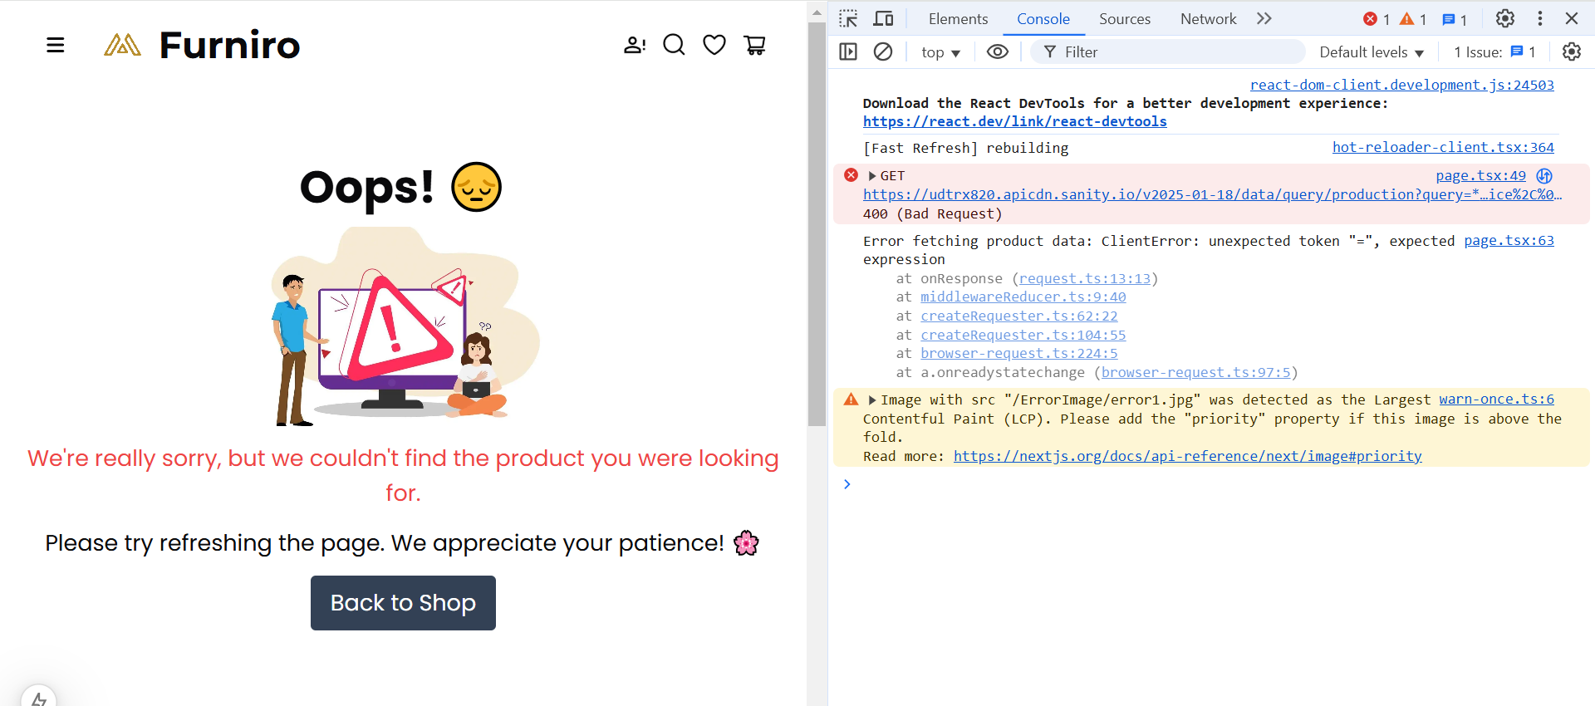

Error Status:

